Project Exception Library

The main thing in this project is the Abstraction Strategy used. So we need not have to change whole code for a small change. This Library is universal library, so we have to use XML file which can be changed by User.
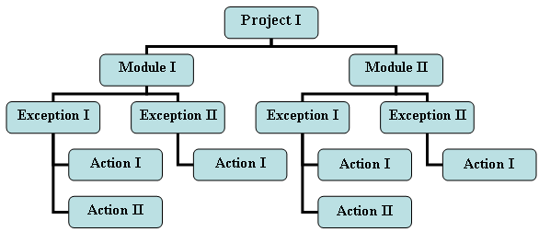

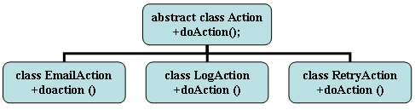

bankHashtable (Project)
Key | Value
createAccount
showBalance

bankHashtable (Project)
Key | Value
createAccount
showBalance

